A



Garda Síochána Inspectorate Customer Service Charter

|  |  |
| --- | --- |
| File Name: | Customer Charter |
| Version No.: | 3.00 |
| Effective From: | March 2018 |
| Maintained by: | Head of Corporate Affairs |
| Date of last Review | January 2024 |
| Approval Status: | Approved |
| Approver: | Chief Inspector |
| Next Review Date: | January 2025 |

Contents

About the Inspectorate 2

Purpose of this Charter 2

Values of the Inspectorate 2

Our Work Plan 3

Our Public Sector Equality and Human Rights Duty 3

Innovation Statement 4

Our Commitment to you 4

Communications 4

Telephone 4

Written and Email Communications 5

Personal Callers 5

Services in Irish 5

Seirbhís i nGaeilge 5

Disability Access Officer 5

Help us to help you 6

# About the Inspectorate

The Garda Síochána Inspectorate is a statutory body, independent in its operation, set up under the Garda Síochána Act 2005, to ensure that the resources available to the Garda Síochána are used efficiently and effectively.

This is achieved by carrying out inspections and measuring the performance of the Garda Síochána by reference to the best standards of comparable police services. Inspections are either self- initiated, or requested by the Minister for Justice or the Policing Authority.

# Purpose of this Charter

The purpose of this Customer Service Charter is to set out the standard of service and behaviour which should underpin our interactions with all customers.

# Values of the Inspectorate

The values that the Inspectorate aspires to in carrying out its work are:

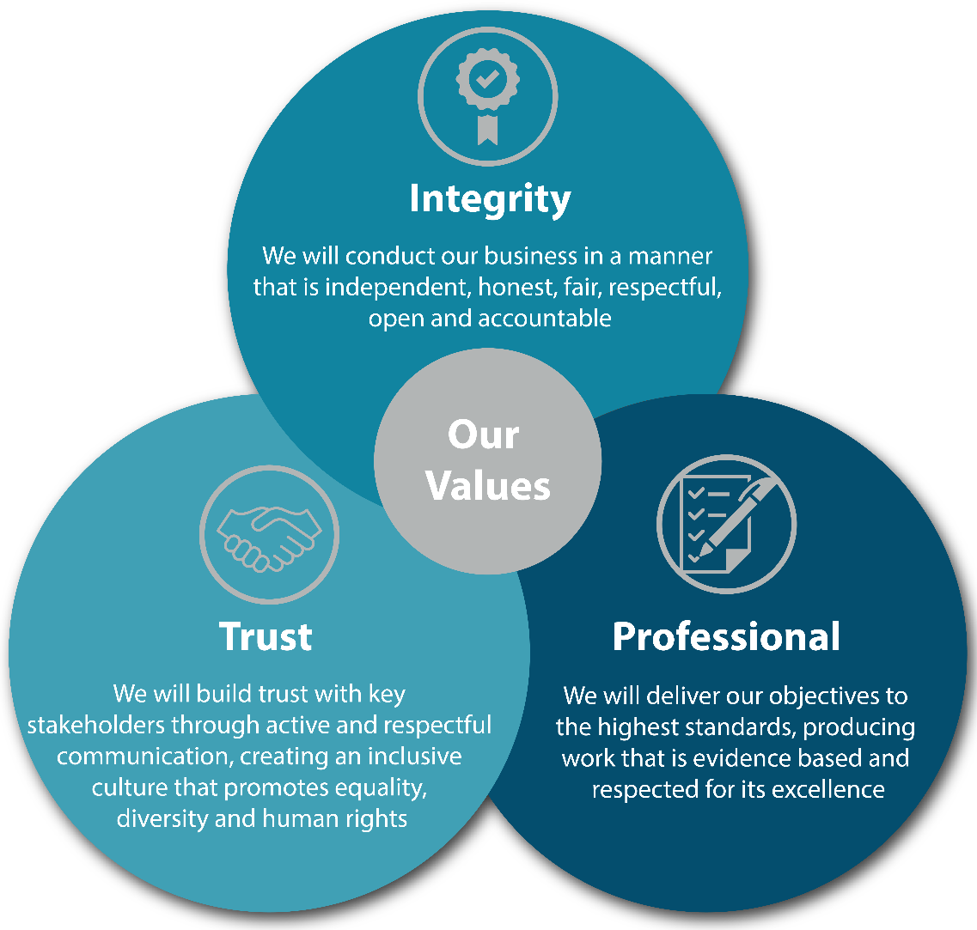

In accordance with the 2005 Act, the Inspectorate is independent in the performance of its functions.

# Our Work Plan

Planned inspections and other Inspectorate activity is set out in our Work Plan. The ever changing policing environment, accelerated by COVID-19 has greatly impacted on crime and offending patterns. As such, inspection activity must be adaptive to react to these types of changes. In response, the Inspectorate has decided to put an annual Work Plan in place, with activity that addresses relevant and high-risk areas. Areas for inspections are selected following consultation with key stakeholders and taking into account the level of risk to human rights and public safety, as well as the level of risk to public confidence, the reputation and the financial management of the Garda Síochána. As part of our Work Plan we also monitor the progress of recommendations made in our previous reports.

The current Work Plan is available at this link <https://www.gsinsp.ie/our-work-plan>

# Our Public Sector Equality and Human Rights Duty

All public bodies in Ireland have responsibility to promote equality, prevent discrimination and protect the human rights of their employees, customers, service users and everyone affected by their policies and plans. This is a legal obligation, called the Public Sector Equality and Human Rights Duty, and it originated in Section 42 of the Irish Human Rights and Equality Commission Act 2014 (the Act).

The Inspectorate is committed to fulfilling its Public Sector Equality and Human Rights Duty by advancing equality, including gender equality, and promoting human rights in all aspects of its work. The Inspectorate’s Public Sector Equality and Human Rights Duty Statement sets out a plan to assess, address and report on the human rights and equality issues relevant to its functions and purpose.

To ensure that the Inspectorate meets its obligations under section 42 of the Irish Human Rights and Equality Commission Act 2014, this document has been screened to confirm that human rights standards are met and that the principles of legality, necessity, proportionality, accountability, equality and non-discrimination underpin the application of the document. This certifies that human rights and equality issues are fully considered in all Inspectorate policies and procedures.

# Innovation Statement

The Public Service Innovation Strategy 2020 has defined innovation as “the creation of a new, viable offering that adds value”. The Inspectorate shares the national vision, set out in the Public Service Innovation Strategy 2020, to “harness the power of innovation to deliver world-class public services in Ireland” and we are committed through innovation to optimise the efficiency and effectiveness of the Inspectorate in the delivery of its objectives over the course of this Statement of Strategy.

The Inspectorate has identified the following key priorities to support the realisation our vision and mission:

* Ensure customers and stakeholders are at the heart any decisions to enhance the quality of the service;
* Listen and engage with customers and stakeholders;
* Create an open culture that will empower, encourage and enable innovation among staff;
* Support and encourage the development of capabilities, knowledge and skills to effectively innovate; and,
* Actively connect and collaborate with other organisations to learn and share knowledge insights in an effort to better optimise efficiency.

# Our Commitment to you

Providing a good service to our customers is very important to us and we aim to achieve this by:

* Giving our customers the best possible service and advice;
* Treating everyone in a proper, fair and impartial manner while at all times remaining courteous and sensitive;
* We aim to ensure that rights to equal treatment and respect for human rights are upheld in the delivery of our services; and
* We aim to meet any special needs our customers may have, where possible.

# Communications

## Telephone

* Our aim is to answer all telephone calls quickly and identify ourselves;
* We will be polite and helpful, and do our best to provide you with clear and correct information; and
* Where we consider that your request or inquiry is more appropriate to another office or body we will help you access that office or body.

We understand that members of the public can sometimes be experiencing difficulties or stress but if callers become abusive, offensive or aggressive to staff members during a telephone call, staff may advise the caller that the call will be terminated if the behaviour continues.

## Written and Email Communications

* We will acknowledge all correspondence, within two working days;
* We will issue final replies within 15 working days and where this is not possible we will issue an interim reply before the 15 day period is up;
* We will give our name and contact details on all correspondence where appropriate;
* We will issue all correspondence in clear language; and
* Where we consider that your request or query is more appropriate to another office or body we will help you access that office or body.

## Personal Callers

* We are not a public office, however we may ask you to make an appointment because of staff work commitments;
* We shall greet visitors politely, and be helpful;
* We will ensure that you are afforded privacy in your dealings with the Office where necessary; and
* Where we consider that your request or inquiry is more appropriate to another office or body, we will help you access that office or body.

# Services in Irish

* Every effort will be made to facilitate persons who wish to conduct their business in Irish.

# Seirbhís i nGaeilge

* Déanfaidh gach iarracht chun freastal ar dhaoine ar mian leo a ngnó a dhéanamh trí mheán na Gaeilge.

# Disability Access Officer

The Department of Justice Access Officer also acts as a point of contact for persons with disabilities who wish to access such services with the Garda Inspectorate.

Email: [accessofficer@justice.ie](mailto:accessofficer@justice.ie)

# Help us to help you

Please let us know what you think of the service we provide by submitting comments, views and suggestions.

We will always endeavour to use this feedback to assist us in providing the best possible customer service.

If you were happy with the service provided please let us know. It’s always nice to hear. You can contact us at [info@gsinsp.ie](mailto:info@gsinsp.ie)



# Cigireacht an Garda Síochána

87 Faiche Stiabhna, Baile Átha Cliath 2, D02 K230,

Éire

**Teil:** +353 (1) 408 6500

**Faics:** +353 (1) 408 6599

**Ríomhphost:** [info@gsinsp.ie](mailto:info@gsinsp.ie)

**Suíomh Gréasáin:** [www.gsinsp.ie](http://www.gsinsp.ie/) Lean muid ar: [www.twitter.com/gsinsp](http://www.twitter.com/gsinsp)

**Garda Síochána Inspectorate**

87 St. Stephen’s Green, Dublin 2,

D02 K230,

Ireland.

**Tel:** +353 (1) 408 6500

**Fax:** +353 (1) 408 6599

**Email:** [info@gsinsp.ie](mailto:info@gsinsp.ie)

**Website:** [www.gsinsp.ie](http://www.gsinsp.ie/) Follow us at [www.twitter.com/gsinsp](http://www.twitter.com/gsinsp)